**RAI AZMAT TARIQ**

**465039**

**SEC A**

Q1.

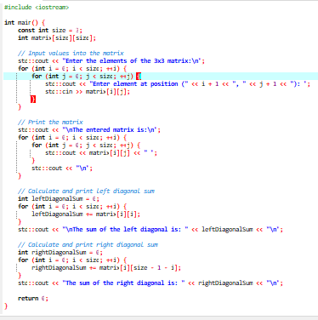

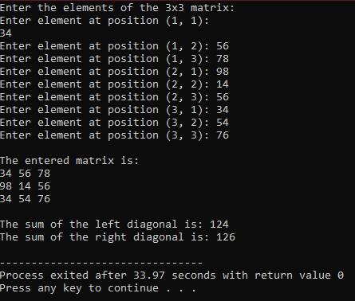

Q2.

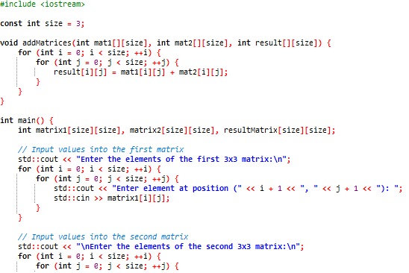

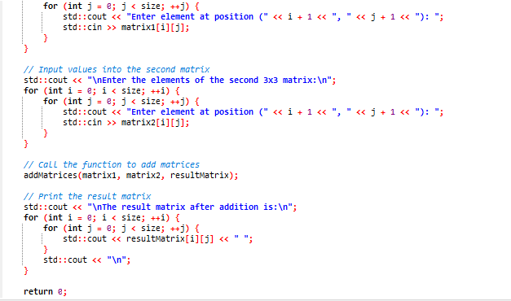

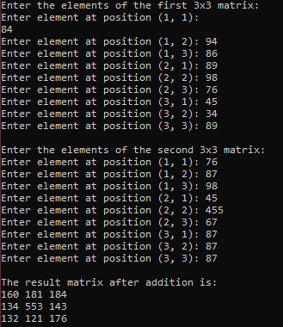

Q3.

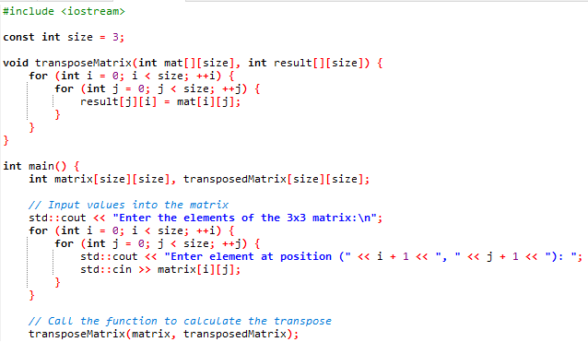

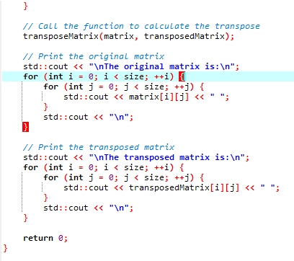

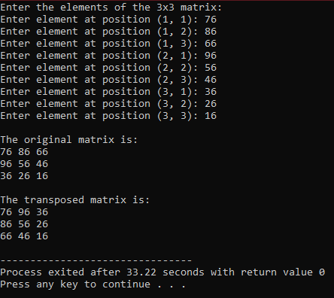

Q4.

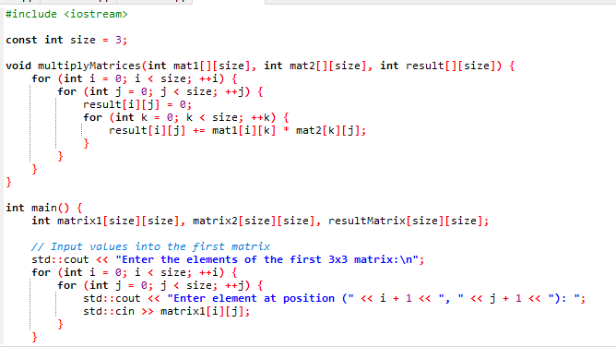

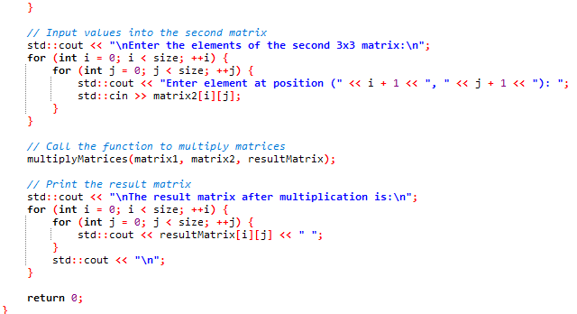

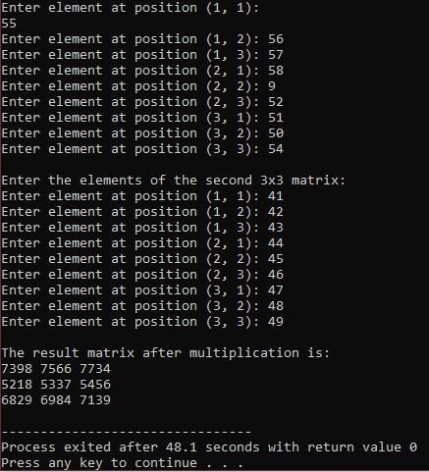

Q5.

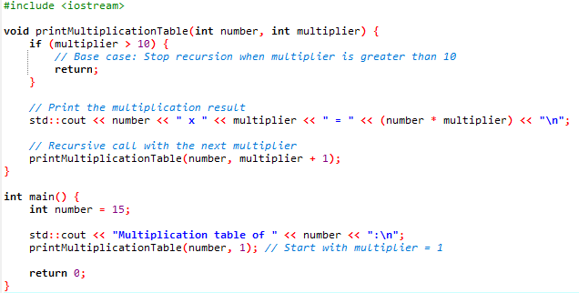

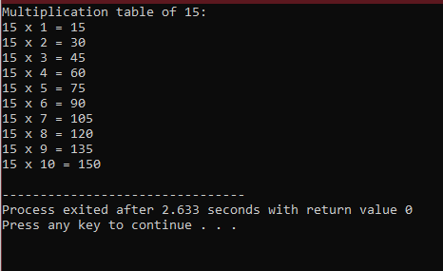

HOMETASK

#include <iostream>

int determinant2x2(int a, int b, int c, int d) {

return a * d - b * c;

}

int determinant3x3(int matrix[3][3]) {

return matrix[0][0] * determinant2x2(matrix[1][1], matrix[1][2], matrix[2][1], matrix[2][2]) -

matrix[0][1] * determinant2x2(matrix[1][0], matrix[1][2], matrix[2][0], matrix[2][2]) +

matrix[0][2] * determinant2x2(matrix[1][0], matrix[1][1], matrix[2][0], matrix[2][1]);

}

int main() {

int originalMatrix[3][3], inverseMatrix[3][3];

std::cout << "Enter elements for the 3x3 matrix:\n";

for (int i = 0; i < 3; ++i)

for (int j = 0; j < 3; ++j)

std::cin >> originalMatrix[i][j];

std::cout << "\nThe original matrix is:\n";

for (int i = 0; i < 3; ++i) {

for (int j = 0; j < 3; ++j)

std::cout << originalMatrix[i][j] << "\t";

std::cout << "\n";

}

int det = determinant3x3(originalMatrix);

if (det != 0) {

int adjointMatrix[3][3];

for (int i = 0; i < 3; ++i)

for (int j = 0; j < 3; ++j) {

int sign = ((i + j) % 2 == 0) ? 1 : -1;

int minorMatrix[2][2] = {

{originalMatrix[(i + 1) % 3][(j + 1) % 3], originalMatrix[(i + 1) % 3][(j + 2) % 3]},

{originalMatrix[(i + 2) % 3][(j + 1) % 3], originalMatrix[(i + 2) % 3][(j + 2) % 3]}

};

adjointMatrix[i][j] = sign * determinant2x2(minorMatrix[0][0], minorMatrix[0][1],

minorMatrix[1][0], minorMatrix[1][1]);

}

for (int i = 0; i < 3; ++i)

for (int j = 0; j < 3; ++j)

inverseMatrix[i][j] = adjointMatrix[j][i] / det;

std::cout << "\nThe inverse matrix is:\n";

for (int i = 0; i < 3; ++i) {

for (int j = 0; j < 3; ++j)

std::cout << inverseMatrix[i][j] << "\t";

std::cout << "\n";

}

} else {

std::cout << “determinat is zero.\n";

}

return 0;

}

